Nth terms diagrams extension solution

 | 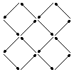 | 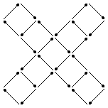
Pattern 1 | Pattern 2 | Pattern 3

In each of the following questions you must show sufficient working so that your reasoning is clear.

- Find a formula for the number of matches in the n^{th} pattern.
Pattern | 1 | 2 | 3
Number of Matches | 4 | 16 | 28

At each stage 12 matches are added so the formula begins $m=\text{12}n$. But on its own this formula gives $m=\text{12}×1=\text{12}$ matches for pattern 1 which is 8 too big. Hence the final formula is $m=\text{12}n−8$. With this formula, putting n = 1, 2 and 3 in turn yields m = 4, 16 and 28 respectively, which are the correct values. So the formula is confirmed as

$$m=\text{12}n−8$$
- Use your formula to predict the number of matches in the 4th pattern.
When n = 4 the formula gives $m=\text{12}×4−8=\text{48}−8=\text{40}$ so the prediction is that pattern 4 will contain 40 matches.
- Draw the 4th pattern to check your result.
Here is pattern number 4:

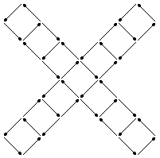

from which it is clear (by counting) that there are indeed 40 matches in the 4th pattern. 

- How many matches are there in the 20th pattern?
When n = 20, the formula gives $m=\text{12}×\text{20}−8=\text{240}−8=\text{232}$ so that the 20th pattern contains 232 matches.
- What is the number of the largest pattern that you can make with 500 matches?
Try putting m = 500:

$$\begin{aligned}\text{12}n−8=\text{500} \\ ⇒\text{12}n=\text{508} \\ ⇒n=\frac{\text{508}}{\text{12}}=\text{42}\frac{4}{\text{12}}=\text{42}\frac{1}{3}\end{aligned}$$

But n must be a whole number so the largest pattern that can be made is number 42. This uses $m=\text{12}×\text{42}−8=\text{504}−8=\text{496}$ matches (with 4 matches left over.)

